##### hmns%20logotype

**Press Information:                                            Public Information:**

Melodie Wade (713) 639-4743 or [mwade@hmns.org](mailto:mwade@hmns.org) (713) 639-4629 or [www.hmns.org](http://www.hmns.org)

Director of Public Relations [Press Site](http://press.hmns.org)

Latha Thomas (713) 639-4712 or [lthomas@hmns.org](mailto:lthomas@hmns.org)

VP of Marketing & Communications

FOR IMMEDIATE RELEASE:

**Stunning images from the Natural History Museum’s 52nd *Wildlife Photographer of the Year* arrive at HMNS**

HOUSTON—Now in its fifty-second year, Wildlife Photographer of the Year is the international leader of innovative visual representation in the natural world. This prestigious competition and resulting exhibition, opening at the Houston Museum of Natural Science Jan. 27, stimulates engagement with the diversity and beauty of the natural world.

On loan from the Natural History Museum in London, this special exhibition features 100 awe-inspiring images, from fascinating animal behavior to breath-taking wild landscapes, which reveal the richness and diversity of life on our planet. Judged by a panel of industry-recognized professionals, the images are selected for their creativity, artistry and technical complexity.

*Wildlife Photographer of the Year* is the most prestigious photography event of its kind, providing a global platform that showcases the natural world’s most astonishing and challenging sights for over 50 years. Launching in 1965 and attracting 361 entries, today the competition receives almost 50,000 entries from 96 countries highlighting its enduring appeal. This year’s 100 award-winning images embark on an international tour that allows them to be seen by millions of people across six continents.

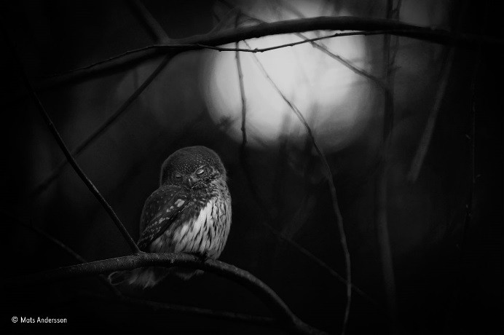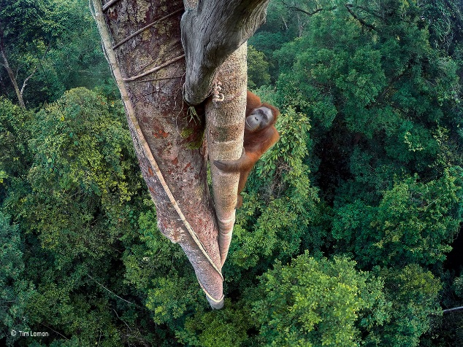

Image by Tim Laman Image by Mats Andersson

-more

*WPY/2*

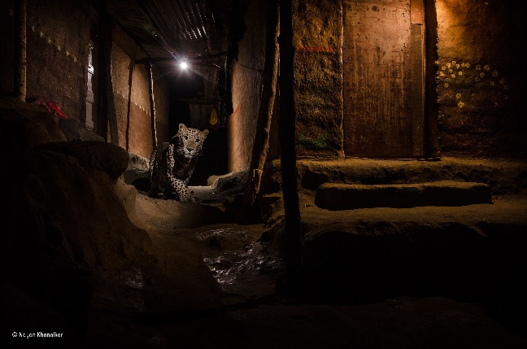

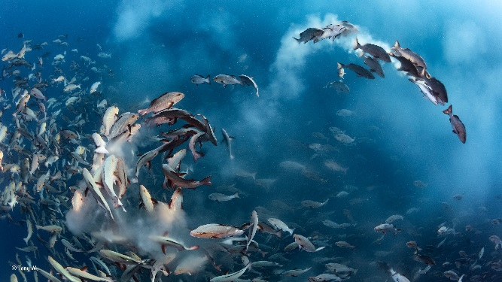

Image by Tony Wu Image by Nayan Khanolkar

Jan English, Head of Touring Exhibitions at the Natural History Museum, says “*Wildlife*

*Photographer of the Year* celebrates the very best nature photography, and it is consistently one of our most successful touring exhibitions, enjoyed by millions every year. These images tell thought-provoking stories about our planet that prompt us all to think differently about the natural world and the future we want to create.”

*Wildlife Photographer of the Year* will be on exhibit from January 27 through June 4, 2017. The exhibit is free for Museum members and with general admission. For tickets or more information on Wildlife Photographer of the Year, visit www.hmns.org or call (713) 639-4629.

**The Houston Museum of Natural Science—**one of the nation’s most heavily attended museums—is a centerpiece of the Houston Museum District. With four floors of permanent exhibit halls, and the Wortham Giant Screen Theatre, Cockrell Butterfly Center, Burke Baker Planetarium, and George Observatory, and as host to world-class and ever-changing touring exhibitions, the Museum has something to delight every age group. With such diverse and extraordinary offerings, a trip to the Houston Museum of Natural Science, located at 5555 Hermann Park Drive in the heart of the Museum District, is always an adventure.

Wildlife Photographer of the Year is owned and developed by the Natural History Museum, London.

###